**Assignment 4.4**

**Answer 1:**

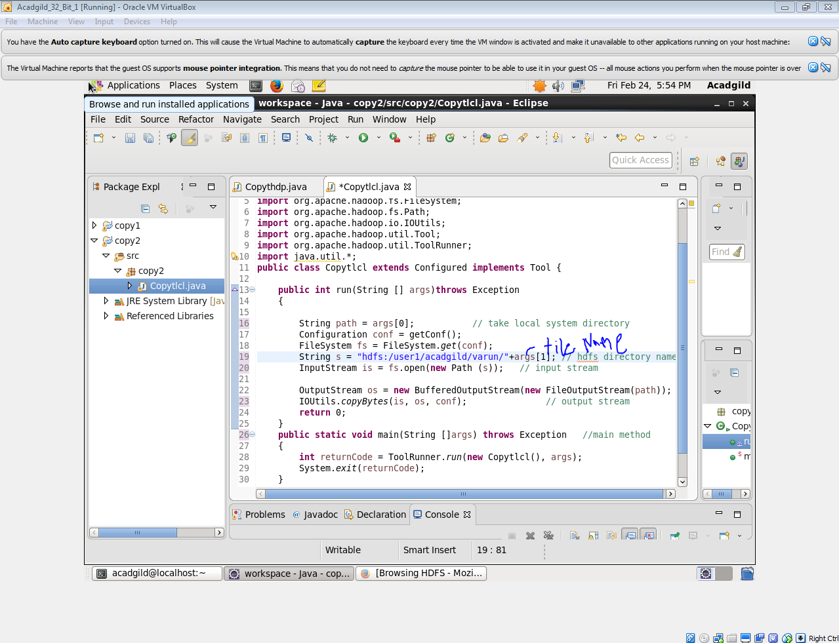

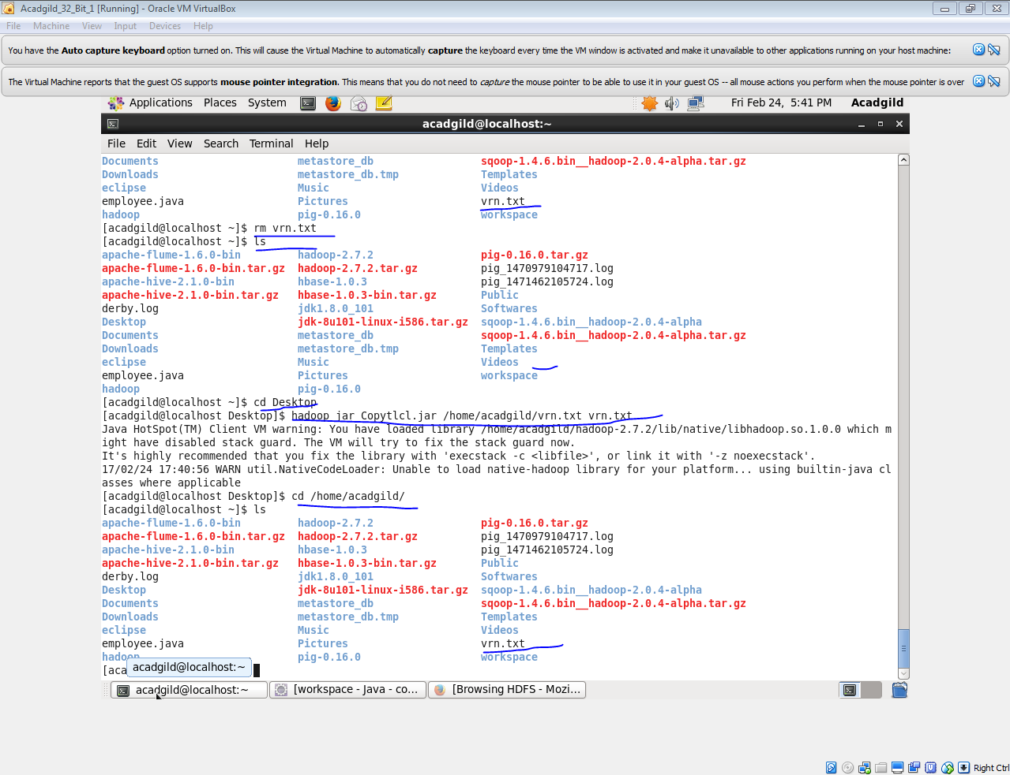

**Answer 2:**

***DFSInputStream :***

* Handles communication of the namenodewith various datanodes.

• Handles integrity of data contained by the blocks.

• Manages data read activity in case of datanodefailure.

• Called internally by FSDataInputStream.

***FSDataInputStream :***

Provides stream (channel) for reading data.

FSDataInputStream

Lets the application read from a file

FSDataInputStreamin = null;

in = fs.open(new Path(uri));

***FSDataOutputStream :***

Provides stream (channel) for writing data.

OutputStreamout = fs.create(new Path(dst));

IOUtils.copyBytes(in, out, 4096, true);

***DFSOutputStream :***

* Handles communication of the namenodewith various datanodes.
* Called internally by FSDataOutputStream.